COURSE SYLLABUS

Type name and number here

Instructor Information
Name: Email: Phone:
Office Location: Office Hours/Student Hours:
Communication Policy: (Responses to emails will be provided within 36 hours, etc.)

Prerequisites for Course
List Prerequisites or enter N/A

Course Description & Objectives
Customized course catalog description and primary objectives
Upon the completion of this course, students will be able to:

Assignments’ description & Alignment with course objectives
Use this space to describe each assignment, when it is due, and the course objective to which it is linked. Tell students where to locate any rubrics for assignments. Another option would be to create and insert a course map like the one below and fill it in.

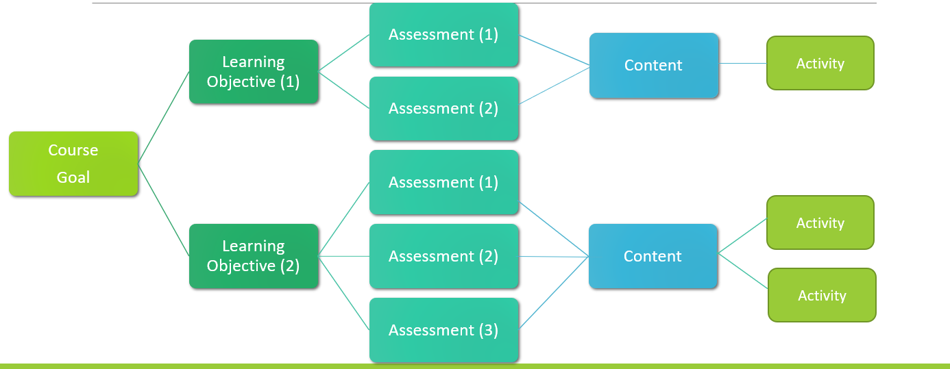

Course Schedule – Alignment of Course Topics, Learning Outcomes, and Assessments
Aligning course topics, student learning outcomes, and assessments benefits both instructor and student – instructors review content/assessment alignment, fill in content gaps or cut content where necessary, clarify learning outcomes for students, and provide clear connections between learning outcomes and assessments for students. Use a simple matrix like the one below to align your course. Add this matrix to your syllabus.
DATE | TOPIC/SUB-TOPIC | LEARNING OUTCOME(S) ALIGNMENT | ASSIGNMENT/  ASSESSMENT(S)

Textbook / Course Readings
List required texts and where to locate them

Course Materials & Equipment
List additional required resources, materials, software, etc., or enter N/A

Morgan Library Services Desk
The Morgan Library Services Desk provides both research (ph. 970-491-1841) and technical (ph. 970-491-7276) support. In addition, you can contact a librarian for assistance at Ask Us! or find a research guide at Research Help.

Classroom Norms (or Community Agreement)
Classroom Norms can be decided by the instructor, created by the instructor with input from students, or co-created by students and instructor. Some example of classroom norms can include:
- We will listen to each other with the intent to understand different perspectives
- We will ask questions when we have them
- We will make sure everyone’s voice is heard
- Etc…
If you ask students about the best classroom experiences they’ve had and solicit their input for classroom norms, you’ll find they most likely have the same expectations as you. When they co-create norms, they tend to have more buy-in to uphold the norms. Norms also give you language to address any behaviors that don’t meet the norms that have been agree upon. The CSU Principles of Community (below) provide an excellent starting point for creating classroom norms.
CSU Principles of Community
Inclusion: We create and nurture inclusive environments and welcome, value and affirm all members of our community, including their various identities, skills, ideas, talents and contributions.
Integrity: We are accountable for our actions and will act ethically and honestly in all our interactions.
Respect: We honor the inherent dignity of all people within an environment where we are committed to freedom of expression, critical discourse, and the advancement of knowledge.
Service: We are responsible, individually and collectively, to give of our time, talents, and resources to promote the well-being of each other and the development of our local, regional, and global communities.
Social Justice: We have the right to be treated and the responsibility to treat others with fairness and equity, the duty to challenge prejudice, and to uphold the laws, policies and procedures that promote justice in all respects.

Diversity and Inclusion
We recommend you have a diversity statement. For example, “Respect for Diversity: It is my intent that students from all diverse backgrounds and perspectives be well served by this course, that students’ learning needs be addressed both in and out of class, and that the diversity that students bring to this class be viewed as a resource, strength and benefit. It is my intent to present materials and activities that are respectful of diversity: gender, sexuality, disability, age, socioeconomic status, ethnicity, race, and culture. Your suggestions are encouraged and appreciated. Please let me know ways to improve the effectiveness of the course for you personally or for other students or student groups. In addition, if any of our class meetings conflict with your religious events, please let me know so that we can make arrangements for you.” For other ideas see this resource from Brown University’s Teaching and Learning Center.

Course Policies (late assignments, make-up exams, revision policy, etc.)
Relevant course policies. Be sure to include rationale for policies using supportive and encouraging language.
e.g. Our group work assignments are designed to provide flexible approaches to participating, and all groups should develop plans that enable all members to contribute equitably. If your group encounters challenges in doing so, please reach out to me so we can work together to devise a solution.
e.g. Because life sometimes throws us unexpected challenges, you will be allowed one late assignment and one dropped quiz grade. If you find you are struggling to keep up with the course, please contact me. I’m here to help.

Grading Policy
Be sure your policy matches your department’s guidelines. These are some potential options.
GRADE | RANGE
A | 90-100%
B | 80-89%
C | 70-79%
D | 60-69%
F | 0-59%
OR
GRADE | RANGE
A+ | 100% to 96.67%
A | <96.67% to 93.33%
A- | <93.33% to 90.0%
B+ | <90.0% to 86.67%
B | <86.67% to 83.33%
B- | <83.33% to 80.0%
C+ | <80.0% to 76.67%
C | <76.67% to 70.0%
D | <70.0% to 60.0%
F | <60.0% to 0.0%
CSU does not use grades of C-, D+, or D-.

[Customize table with each graded assignment]
ASSIGNMENT | GRADE POINTS | GRADE PERCENTAGE
Discussions
Written Assignments
Quiz/Exam
Participation
Group Work
Project
Presentation
Total: |  | 100 %

Please add to your syllabus this QRN code and/or short link (https://col.st/2FA2g) with a statement informing students that the linked page provides policies relevant to their courses and resources to help with various challenges they may encounter.

